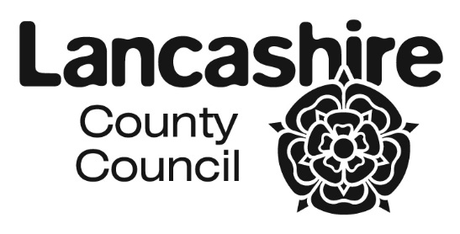
CO-ORDINATED ADMISSION SCHEME FOR
LANCASHIRE SCHOOLS AND ACADEMIES 2023/24
SEPTEMBER 2023 INTAKES

SECONDARY |  | PRIMARY
DATE | ACTION | DATE | ACTION
1 September 2022 | Online application system goes live and requests for paper forms / booklets accepted and considered | 1 September 2022 | Online application system goes live and requests for paper forms / booklets accepted and considered
31 October 2022 | Closing date for applications  (statutory) | Sunday 15 January 2023 | Closing date for applications  (statutory)
7 November 2022 | Secondary schools / academies to forward any paper applications to Area Pupil Access Teams | 20 January 2023 | Primary schools / academies to forward any paper applications to Area Pupil Access Teams
21 November 2022 | Preferences information exchange with other Local Authorities | 27 January 2023 | Preferences information exchange with other Local Authorities
5 December 2022 | Information to be exchanged with Own Admission Authority Schools | 3 February 2023 | Information to be exchanged with Own Admission Authority Schools
12 December 2022 | Admission authority to confirm intention to exceed PAN with the LA | 10 February 2023 | Admission authority to confirm intention to exceed PAN with the LA
18 December 2022 | Prioritised (ranked) lists back to the Local Authority | 28 February 2023 | No further address changes can be accepted.
15 January 2023 | No further address changes can be accepted. | 17 March 2023 | Prioritised (ranked) lists back to the Local Authority
23 January 2023 | Further exchange of lists with other admission authorities | 24 March 2023 | Further exchange of lists with other admission authorities
13 February 2023 | No changes at all can be made to offer letters after this date | 31 March 2023 | No changes at all can be made to offer letters after this date
24 February 2023 | Issue finalised offer lists to secondary schools / academies | 17 April 2023 | Issue finalised offer lists to primary schools / academies
1 March 2023 | Issue offer letters/emails.  (statutory date is 1st March or the next working day) | 17 April 2023 | Issue offer letters/emails.  (statutory date or next working day)

The closing dates and offer dates are national statutory requirements. The dates of exchanges of information may on occasion vary slightly by agreement to take into account localised issues associated with workload and / or specific situations affecting a school / academy or a group of establishments. Occasionally delays may occur as neighbouring authorities will be working to different timetables.

Where a statutory offer date is on a weekend or public holiday Lancashire's online system will go live on the next working day.

